FORM 1.1
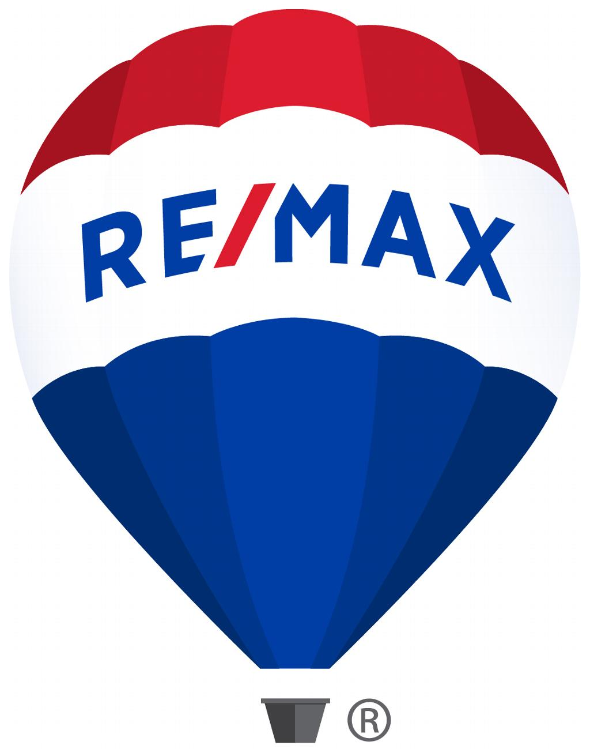 | RE/MAX SPECIAL EVENTS TEAM  Event Request Application

Date(s) Requested: ______________________ City/Town, Prov of Event: ______________________

Item(s) Requested: Hot Air Balloon Flight ___
Hot Air Balloon Tether Up to 75 Min ___ Up to 150 Min ___
Static Basket & Burner Presentation Up to 75 Min ___ Up to 120 Min ___
Parade Display ___
Inflatable RE/MAX Balloon ___
Jumping Castle/Slide ___
Pop Up Tent Set Up/Take Down ___
School Presentations with Balloon ___
School Presentations without Balloon ___

Broker/Owner: ___________________________________________
Office: ___________________________________________
Office Address: ___________________________________________
___________________________________________

Telephone: Office: ( )__________________
Cell: ( )__________________
Fax: ( )__________________
Email: __________________________________

Name of Event: __________________________________________
Location of Event: __________________________________________
Event Website: __________________________________________
Date and Time Requested: _____________________________________
Approximate Attendance: ____________________
Contact Person at Event: _____________________
Address: _________________________________________________
__________________________________________________

Telephone: Office: ( )__________________
Cell: ( )__________________
Fax: ( )__________________
Email: _________________________________________
Notes:__________________________________________________________________________________________________________________________________________________________________________________________________________________________________________________________________________________________________________________________________________________________________

Broker/Associate Signature: _____________________________Date: _________________

This is a date/event request only. If the date is available and your event is approved you will receive a confirmation in writing from Sundance Balloons.

